PROPRIETARY AND CONFIDENTIAL

Clanton PD Printer Remediation for Windows 7 Workstations

IMPORTANT NOTE: THIS PROCEDURE IS RESTRICTED TO 64-BIT (x64) VERSIONS OF WINDOWS 7 ONLY. DO NOT RESTART THE PC BEFORE THIS PROCEDURE IS COMPLETE.

PROCESS ONE—REMOVE ALL PRINT DRIVER/PROCESSOR FILES AND CORRESPONDING REGISTRY ENTRIES

- Logon to affected workstation (AW) with administrative user account
- Stop the “Print Spooler” service
- Open Windows Explorer
- Navigate to: C:\Windows\System32\spool\drivers\x64\3\
- Delete all files and folders in this directory
- Navigate to: C:\Windows\System32\spool\prtprocs\x64\
- Delete all files and folders in this directory
- Open the registry editor (Click Start and type regedit.exe in search box)
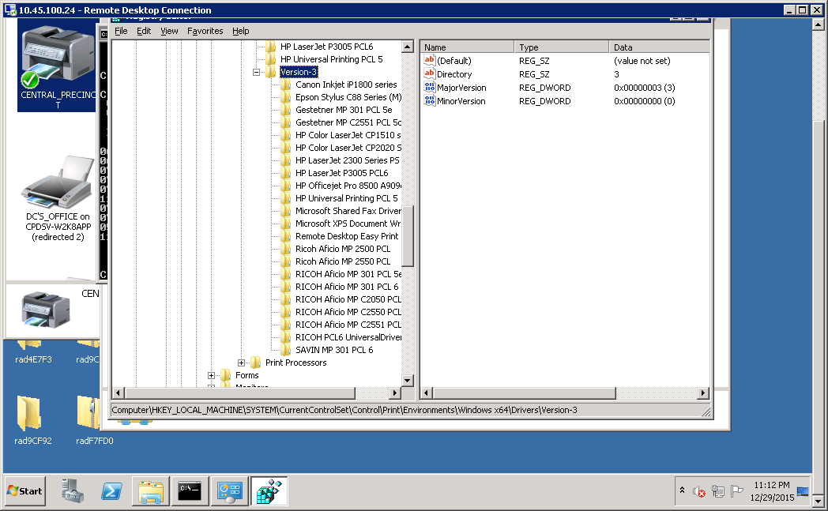
- In registry editor, navigate to: HKEY_LOCAL_MACHINE\SYSTEM\CurrentControlSet\Control\Print\Environments\Windows x64\Drivers\Version-3
You will see entries similar to those shown below:

- Delete all registry keys under “Version-3,” as shown below:

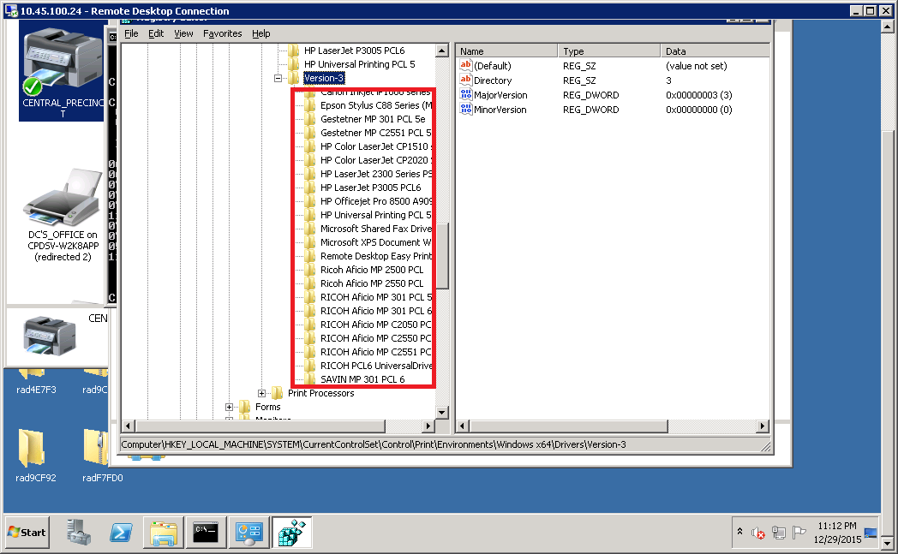

PROCESS TWO – DELETE PRINT PROCESSORS FROM REGISTRY

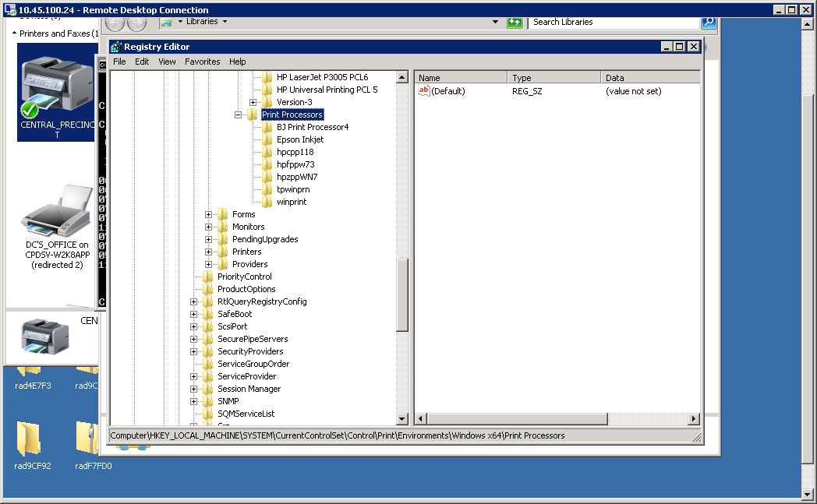
- Remaining in the registry editor, navigate to: HKey_local_Machine\SYSTEM\CURRENTCONTROLSET\CONTROL\PRINT\ENVIRONMENTS\WINDOWS X64\PRINT PROCESSORS\ as shown below:

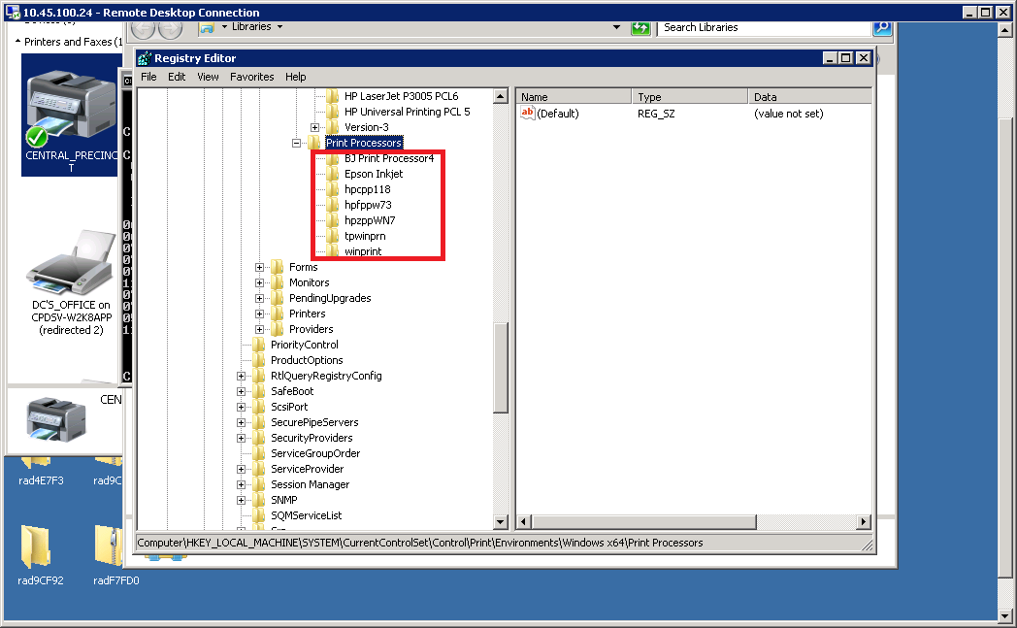
- Delete the keys below “Print Processors,” as shown below:
- Deletion of all print processors, drivers, and corresponding registry entries is now complete

PROCESS THREE – RESTORE PRINT PROCESSORS AND CORRESPONDING REGISTRY ENTRIES
- Open RDP to .23
- Open RDP session to affected workstation (AW)
- On, AW, open Explorer and navigate to: C:\Windows\System32\spool\PRTPROCS\x64\
- Copy folder on desktop of .23 named PRINTPROC to AW
- Copy printproc.reg from desktop of .23 to AW
- Copy contents from PRINTPROC folder to AW’s C:\Windows\System32\spool\PRTPROCS\x64\ directory
- Right-click on printproc.reg and click “Merge”
- Restart the Print Spooler service
- Add a printer with Window’s “Devices and Printers” tool. For example, ”NORTH_PRECINCT” There should be no installation errors
- Logoff PC and logon as the workstation’s primary user
- The logon script should execute, installing print drivers, without errors
- Test printing

*** END OF PROCEDURE ***
V1.0, 30-DEC-2015, GM

